|  |  |  |  |  |  |  |  |  |  |  |  |  |  |  |  |
| --- | --- | --- | --- | --- | --- | --- | --- | --- | --- | --- | --- | --- | --- | --- | --- |
| **Actor:** Customer  **Summary:** This use case is about how to buy a ticket  **Goal:** Customer can buy ticket successful  **Triggers:** N/A  **Pre-conditions:**  Customer has logged into system  **Post-conditions:** N/A  **Main Success Scenario:**   |  |  |  | | --- | --- | --- | | Step | Actor Action | System Response | | 1 | Click on an event | Navigate to Event page | | 2 | Choose a ticket and click on “Đặt vé” button | Navigate to Buy Ticket page | | 3 | Click on “Xác nhận” button | Navigate to PayPal page | | 4 | Complete transaction on Paypal | Navigate to Buy Success page |   **Alternative Scenario:** N/A  **Exceptions:** N/A  **Relationships:**  N/A  **Business Rules:** N/A |

###### **3.2.2.2.14 Post Ticket**

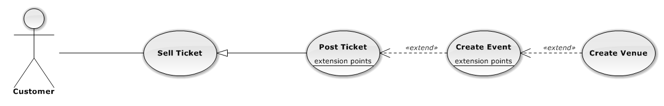

|  |  |  |  |  |
| --- | --- | --- | --- | --- |
| USE CASE – POST TICKET | | | | |
| Use-case No. | UC02.14 | Use-case Version | | 1.0 |
| Use-case Name | Post Ticket | | | |
| Author | TungDN | | | |
| Date | 06/01/2013 | Priority | Normal | |
| **Actor:** Customer  **Summary:** This use case is about how to post a ticket  **Goal:** Customer can post ticket successful  **Triggers:** N/A  **Pre-conditions:**  Customer has logged into system  **Post-conditions:** Ticket is posted successful  **Main Success Scenario:**   |  |  |  | | --- | --- | --- | | Step | Actor Action | System Response | | 1 | Click on “Bán vé” tab | Navigate to Sell ticket page | | 2 | Click “Bán vé” link | Navigate to Create ticket page | | 3 | Fill mandatory fields and click “Đăng vé” button | - Does validation, check conflict and save data  - Navigate back to Home page |   **Alternative Scenario:**   |  |  |  | | --- | --- | --- | | Step | Actor Action | System Response | | 1 | Click on “Bán vé” tab | Navigate to Sell ticket page | | 2 | Click on “Bán vé” link | Navigate to Create ticket page | | 3 | Check “Tạo mới” box in “Tên sự kiện” field and input new event name | Display notice message about post ticket | | 4 | Fill mandatory fields and click “Đăng vé” button | - Does validation, check conflict and save data  - Navigate back to Home page |  |  |  |  | | --- | --- | --- | | Step | Actor Action | System Response | | 1 | Click on “Bán vé” tab | Navigate to Sell ticket page | | 2 | Click on “Bán vé” link | Navigate to Create ticket page | | 3 | Check on “Tạo mới” box in “Tên sự kiện” field and input new event name | Display notice message about post ticket | | 4 | Check “Tạo mới” box in “Nơi tổ chức” field and input new venue | Input information normally | | 5 | Fill mandatory fields and click “Đăng vé” button | - Does validation, check conflict and save data  - Navigate back to Home page |   **Exceptions:**   |  |  |  | | --- | --- | --- | | Step | Actor Action | System Response | | 1 | Same as Main Success Scenario | | | 2 | Same as Main Success Scenario | | | 3 | Does not fill all required field or enters invalid data | Display warning message to notify the missing field or invalid data |   **Relationships:**  N/A  **Business Rules:** N/A | | | | |

###### 

###### **3.2.2.2.15 Edit Posted Ticket**

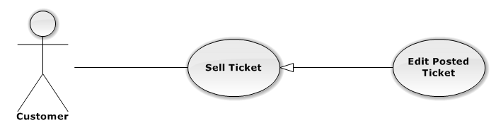

|  |  |  |  |  |
| --- | --- | --- | --- | --- |
| USE CASE – EDIT POSTED TICKET | | | | |
| Use-case No. | UC02.15 | Use-case Version | | 1.0 |
| Use-case Name | Edit Posted Ticket | | | |
| Author | TungDN | | | |
| Date | 06/01/2013 | Priority | Normal | |
| **Actor:** Customer  **Summary:** This use case is about how to edit posted ticket information  **Goal:** Customer can edit ticket information successful  **Triggers:** N/A  **Pre-conditions:**  Ticket want to edit is not in transaction  **Post-conditions:** Ticket is updated successful  **Main Success Scenario:**   |  |  |  | | --- | --- | --- | | Step | Actor Action | System Response | | 1 | Click on “Bán vé” tab | Navigate to Sell ticket page | | 2 | Click on “Danh sách rao bán” link | Navigate to List posted ticket page | | 3 | Click on a posted ticket | Display ticket information | | 4 | Click on “Chỉnh sửa” button | Navigate to Edit ticket page | | | | | |

* Sytem can check status of event and transaction after period of time.

#### 3.1.6 Authorized User

* An authorized user can change password and personal information.

### 3.2 System Requirement Specification

#### 3.2.1 External Interface Requirements

##### **3.2.1.1 User Interfaces**

* The design should be simple and user-friendly. Violet and dark will be 2 main colors of the website while charts may have more color to visually express data more effectively.
* The menu bar should be on the left and not take too much space of the screen. It consists of the list of main functions of the system that users can access.
* The design should be responsive. It means that the web components should be scaled according to a range of resolutions and devices to provide a consistent experience, no matter what.

##### **3.2.1.2 Hardware Interfaces**

* To access to the system, users only need any type of computer, tablet, or mobile phone with a fair internet connection.

##### **3.2.1.3 Software Interfaces**

* At the server side, the system should run on top of Windows 7, Windows Server 2008 R2 or later versions of Windows Server. Besides, Microsoft .NET Framework 4.5 and MVC 4 should be installed on the server. The database management system use for Drop_It is SQL Server 2012 Express.
* At the client side, users can use any modern browser that supports JavaScript and HTML 5 to access to the system.

##### **3.2.1.4 Communications Protocol**

HTTP is the protocol used for loading the web site in browsers.

###### **3.2.2.1.2 View Category**

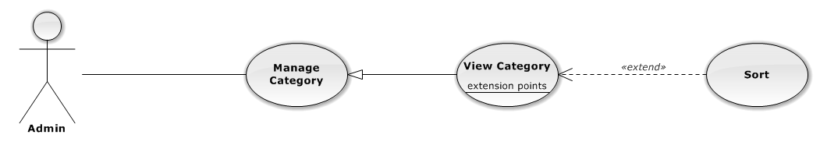

|  |  |  |  |
| --- | --- | --- | --- |
| USE CASE – VIEW CATEGORY | | | |
| Use-case No. | UC01.02 | Use-case Version | 1.0 |
| Use-case Name | View Category | | |
| Author | HieuCM | | |
| Date | 06/01/2013 | Priority | Normal |
| **Actor:** Admin  **Summary:** This use case is about how admin view category  **Goal:** View category successful  **Triggers:** N/A  **Pre-conditions:** N/A  **Post-conditions:** N/A  **Main Success Scenario:**   |  |  |  | | --- | --- | --- | | Step | Actor Action | System Response | | 1 | Click on “Danh mục” tab | Navigate to Manage Category page | | 2 | Click “Hiển thị” tab | Display showed category list | | 3 | Click “Không hiển thị” tab | Display not showed category list |   **Alternative Scenario:**   |  |  |  | | --- | --- | --- | | Step | Actor Action | System Response | | 1 | Click on “Danh mục” tab | Navigate to Manage Category page | | 2 | Click “Hiển thị” tab or “Không hiển thị” tab | Display showed/hidden category list | | 3 | Click on “Tên danh mục” label | Display list of categories sort by category name |   **Exceptions:**  N/A  **Relationships:**  N/A  **Business Rules:** N/A | | | |

|  |  |  |  |  |  |  |  |  |  |
| --- | --- | --- | --- | --- | --- | --- | --- | --- | --- |
| **Actor:** Admin  **Summary:** This use case is about how to show category after hidden  **Goal:** Category is shown  **Triggers:** N/A  **Pre-conditions:** Category is hidden  **Post-conditions:** Show category successful  **Main Success Scenario:**   |  |  |  | | --- | --- | --- | | Step | Actor Action | System Response | | 1 | Click on “Danh mục” tab | Navigate to Manage Category page | | 2 | Choose Category in hidden category and click “Hiện” button | Selected category is shown successfully |   **Alternative Scenario:**  N/A  **Exceptions:** N/A  **Relationships:**  N/A  **Business Rules:** N/A |

###### **3.2.2.1.8 View User**

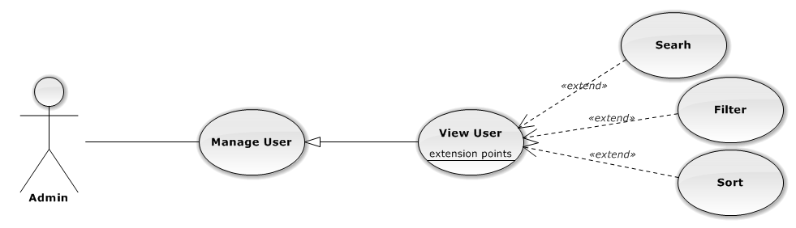

|  |  |  |  |
| --- | --- | --- | --- |
| USE CASE – VIEW USER | | | |
| Use-case No. | UC01.08 | Use-case Version | 1.0 |
| Use-case Name | View User | | |
| Author | PhongLK | | |
| Date | 06/01/2013 | Priority | Normal |
| **Actor:** Admin  **Summary:** This use case is about admin view users  **Goal:** View users successful  **Triggers:** N/A  **Pre-conditions:** N/A  **Post-conditions:** N/A  **Main Success Scenario:**   |  |  |  | | --- | --- | --- | | Step | Actor Action | System Response | | 1 | Click on “Người dùng”tab | - Navigate to Manage User page  - Display list of users | | 2 | Click on a user | Display user information | | | | |

###### **3.2.2.1.12 Disallow User Selling**

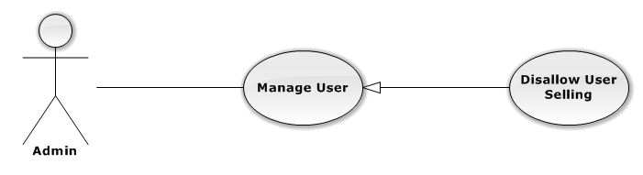

|  |  |  |  |
| --- | --- | --- | --- |
| USE CASE – DISALLOW USER SELLING | | | |
| Use-case No. | UC01.12 | Use-case Version | 1.0 |
| Use-case Name | Disallow User Selling | | |
| Author | PhongLK | | |
| Date | 06/01/2013 | Priority | Normal |
| **Actor:** Admin  **Summary:** This use case is about how to disallow user selling  **Goal:** Disallow user selling successful  **Triggers:** N/A  **Pre-conditions:** User is allowed to sell  **Post-conditions:** User is disallowed to sell  **Main Success Scenario:**   |  |  |  | | --- | --- | --- | | Step | Actor Action | System Response | | 1 | Click on “User” button | Navigate to Manage User page | | 2 | Choose user want to allow selling tick on “Được bá” checkbox | - Allow user selling successful  - Display message disallow user selling success on top |   **Alternative Scenario:**  N/A  **Exceptions:** N/A  **Relationships:**  N/A  **Business Rules:** N/A | | | |

###### **3.2.2.1.13 View Event**

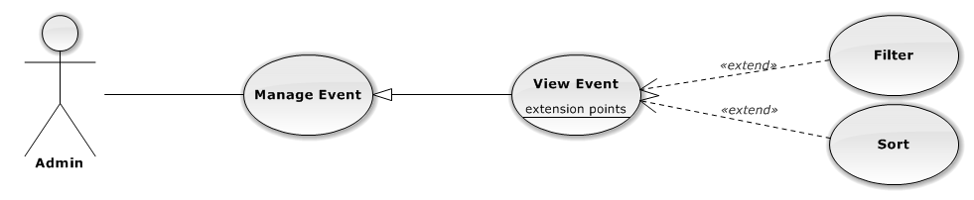

|  |  |  |  |
| --- | --- | --- | --- |
| USE CASE – VIEW EVENT | | | |
| Use-case No. | UC01.13 | Use-case Version | 1.0 |
| Use-case Name | View Event | | |

|  |  |  |  |
| --- | --- | --- | --- |
| |  |  |  | | --- | --- | --- | |  | button | successful |   **Alternative Scenario:**  N/A  **Exceptions:** N/A  **Relationships:**  N/A  **Business Rules:** N/A |

###### **3.2.2.1.19 View Request**

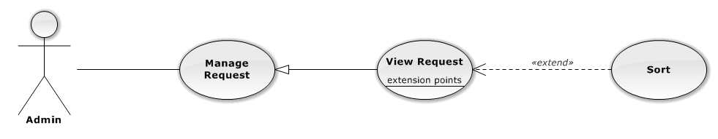

|  |  |  |  |
| --- | --- | --- | --- |
| USE CASE – VIEW REQUEST | | | |
| Use-case No. | UC01.19 | Use-case Version | 1.0 |
| Use-case Name | View Request | | |
| Author | TungNT | | |
| Date | 06/01/2013 | Priority | Normal |
| **Actor:** Admin  **Summary:** This use case is about how admin view request  **Goal:** Admin view request successful  **Triggers:** N/A  **Pre-conditions:** N/A  **Post-conditions:** N/A  **Main Success Scenario:**   |  |  |  | | --- | --- | --- | | Step | Actor Action | System Response | | 1 | Click on “Yêu cầu” tab | Navigate to Manage Request page |   **Alternative Scenario:**   |  |  |  | | --- | --- | --- | | Step | Actor Action | System Response | | 1 | Click on “Yêu cầu” tab | Navigate to Manage Request page | | 2 | Click on “Sự kiện” label or Click on  “Người đăng” label | Display requests sort by event name or  Display requests sort by user name |   **Exceptions:** N/A  **Relationships:**  N/A  **Business Rules:** N/A | | | |

###### **3.2.2.1.20 Close Request**

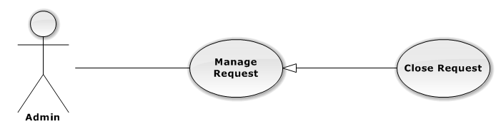

|  |  |  |  |
| --- | --- | --- | --- |
| USE CASE – CLOSE REQUEST | | | |
| Use-case No. | UC01.20 | Use-case Version | 1.0 |
| Use-case Name | Close Request | | |
| Author | TungNT | | |
| Date | 06/01/2013 | Priority | Normal |
| **Actor:** Admin  **Summary:** This use case is about how to close request after created  **Goal:** N/A  **Triggers:** N/A  **Pre-conditions:** Request is created  **Post-conditions:** Close request successful  **Main Success Scenario:**   |  |  |  | | --- | --- | --- | | Step | Actor Action | System Response | | 1 | Click on “Yêu cầu” tab | Navigate to Manage Request page | | 2 | Choose request want to close and click on “Đóng” button | Display confirm message | | 3 | Click on “Yes” button | Selected request is closed successful |   **Alternative Scenario:**  N/A  **Exceptions:** N/A  **Relationships:**  N/A  **Business Rules:** N/A | | | |

###### **3.2.2.1.21 View Ticket**

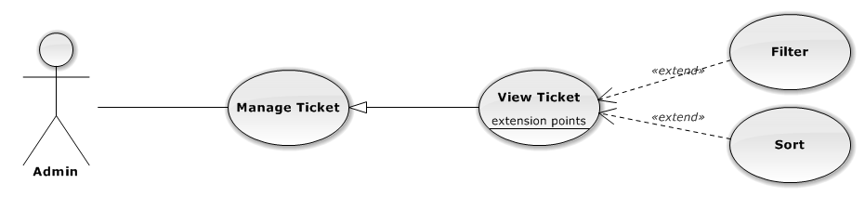

|  |  |  |  |
| --- | --- | --- | --- |
| USE CASE – VIEW TICKET | | | |
| Use-case No. | UC01.21 | Use-case Version | 1.0 |

|  |  |  |  |  |  |  |  |  |  |  |  |  |
| --- | --- | --- | --- | --- | --- | --- | --- | --- | --- | --- | --- | --- |
| |  |  |  | | --- | --- | --- | | 1 | Click on “Vé” tab | Navigate to Manage Ticket page | | 2 | Click on “Tạm hoãn” tab | Show list of disapproved ticket | | 3 | Choose a ticket and click on “Xóa” button | Display confirm message | | 4 | Click “Yes” button | Delete ticket successful |   **Alternative Scenario:**  N/A  **Exceptions:** N/A  **Relationships:**  N/A  **Business Rules:** N/A |

###### **3.2.2.1.26 View Venue**

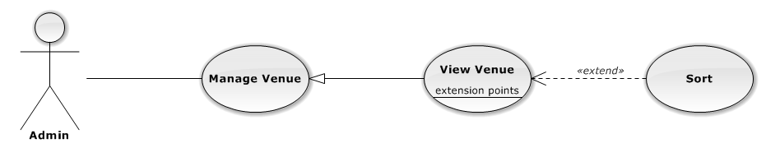

|  |  |  |  |
| --- | --- | --- | --- |
| USE CASE – VIEW VENUE | | | |
| Use-case No. | UC01.26 | Use-case Version | 1.0 |
| Use-case Name | View Venue | | |
| Author | TungNT | | |
| Date | 06/01/2013 | Priority | Normal |
| **Actor:** Admin  **Summary:** This use case is about how admin view venue  **Goal:** View venue successful  **Triggers:** N/A  **Pre-conditions:** N/A  **Post-conditions:** N/A  **Main Success Scenario:**   |  |  |  | | --- | --- | --- | | Step | Actor Action | System Response | | 1 | Click on “Địa điểm” tab | Navigate to Manage Venue page | | 2 | Click on “Chưa duyệt” tab | Display disapproved venue list | | 3 | Click on “Đã duyệt” tab | Display approved venue list | | 4 | Move mouse to a venue | Display hover about venue information |   **Alternative Scenario:** | | | |

|  |  |  |  |
| --- | --- | --- | --- |
| Use-case No. | UC01.31 | Use-case Version | 1.0 |
| Use-case Name | Disapprove Venue | | |
| Author | TungNT | | |
| Date | 06/01/2013 | Priority | Normal |
| **Actor:** Admin  **Summary:** This use case is about how to disapprove venue  **Goal:** Venue is approved  **Triggers:** N/A  **Pre-conditions:** Venue is already approved  **Post-conditions:** Disapprove venue successful  **Main Success Scenario:**   |  |  |  | | --- | --- | --- | | Step | Actor Action | System Response | | 1 | Click on “Địa điểm” tab | Navigate to Venue page | | 2 | Click on “Đã duyệt” tab | Show list of approved venues | | 3 | Choose venue want to disapprove and click on “Bỏ duyệt” button | Disapprove selected venue successful |   **Alternative Scenario:**  N/A  **Exceptions:** N/A  **Relationships:**  N/A  **Business Rules:** N/A | | | |

###### **3.2.2.1.32 View Transaction**

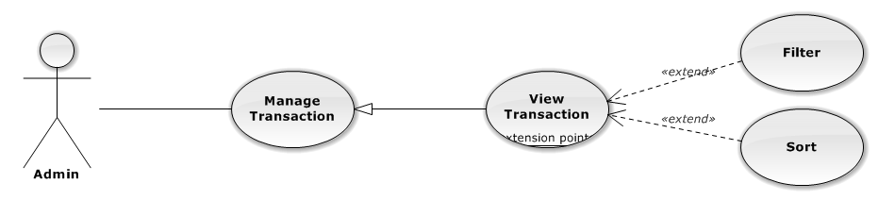

|  |  |  |  |
| --- | --- | --- | --- |
| USE CASE – VIEW TRANSACTION | | | |
| Use-case No. | UC01.32 | Use-case Version | 1.0 |
| Use-case Name | View Transaction | | |
| Author | HieuCM | | |
| Date | 06/01/2013 | Priority | Normal |
| **Actor:** Admin  **Summary:** This use case is about how admin view transaction  **Goal:** View transaction successful  **Triggers:** N/A  **Pre-conditions:** N/A  **Post-conditions:** N/A  **Main Success Scenario:** | | | |

|  |  |  |  |  |  |  |  |  |  |  |  |  |  |  |  |  |  |  |  |  |  |
| --- | --- | --- | --- | --- | --- | --- | --- | --- | --- | --- | --- | --- | --- | --- | --- | --- | --- | --- | --- | --- | --- |
| **Summary:** This use case is about how to update transaction  **Goal:** Update transaction successful  **Triggers:** N/A  **Pre-conditions:** N/A  **Post-conditions:** Transaction is updated  **Main Success Scenario:**   |  |  |  | | --- | --- | --- | | Step | Actor Action | System Response | | 1 | Click on “Giao dịch” tab | Navigate to Manage Transation page | | 2 | Click on a “Đã thanh toán” tab | Display paid transaction list | | 3 | Choose a transaction and click “Giao hàng” button | - Transaction disappeared  - Transaction status changed to delivering | | 4 | Click on a “Giao hàng” tab | Show delivering transaction list | | 5 | Choose a transaction and click “Nhận hàng” button | - Transaction disappeared  - Transaction status changed to received | | 6 | Click on a “Đã nhận hàng” tab | Display received transaction list |   **Alternative Scenario:**  N/A  **Exceptions:** N/A  **Relationships:**  N/A  **Business Rules:** N/A |

###### **3.2.2.1.34 View Setting**

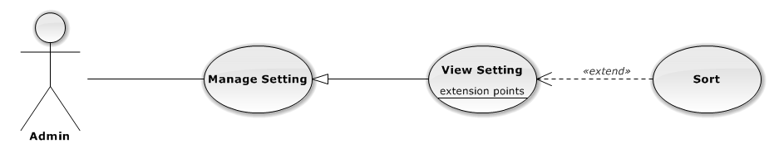

|  |  |  |  |
| --- | --- | --- | --- |
| USE CASE – VIEW SETTING | | | |
| Use-case No. | UC01.34 | Use-case Version | 1.0 |
| Use-case Name | View Setting | | |
| Author | TungNT | | |
| Date | 06/01/2013 | Priority | Normal |
| **Actor:** Admin  **Summary:** This use case is about how admin view setting  **Goal:** View setting successful  **Triggers:** N/A | | | |

###### **3.2.2.3.3 View Event Detail**

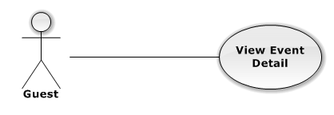

|  |  |  |  |  |
| --- | --- | --- | --- | --- |
| USE CASE – VIEW EVENT DETAIL | | | | |
| Use-case No. | UC03.03 | Use-case Version | | 1.0 |
| Use-case Name | View Event Detail | | | |
| Author | TungDN | | | |
| Date | 01/06/2013 | Priority | Normal | |
| **Actor:** Customer, Authorized User  **Summary:** This use case is about how actor views event detail  **Goal:** Actor can view event detail successful  **Triggers:** N/A  **Pre-conditions:** N/A  **Post-conditions:** N/A  **Main Success Scenario:**   |  |  |  | | --- | --- | --- | | Step | Actor Action | System Response | | 1 | Click on an event | Navigate to Event Details page |   **Alternative Scenario:** N/A  **Exceptions:** N/A  **Relationships:**  N/A  **Business Rules:** N/A | | | | |

###### **3.2.2.3.4 Search Event by Name**

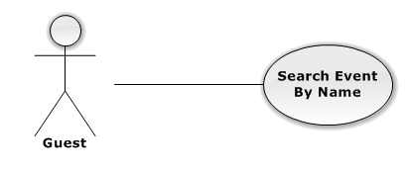

|  |  |  |  |  |
| --- | --- | --- | --- | --- |
| USE CASE – SEARCH EVENT BY NAME | | | | |
| Use-case No. | UC03.04 | Use-case Version | | 1.0 |
| Use-case Name | Search Event by Name | | | |
| Author | HieuCM | | | |
| Date | 01/06/2013 | Priority | Normal | |
| **Actor:** Customer, Authorized User, Guest  **Summary:** This use case is about how actor search event by name  **Goal:** Actor can search event successful  **Triggers:** N/A  **Pre-conditions:** N/A  **Post-conditions:** N/A  **Main Success Scenario:**   |  |  |  | | --- | --- | --- | | Step | Actor Action | System Response | | 1 | Input information want to find in text box | Make suggestion when actor input more than 1 character | | 2 | Click on search label or press Enter key | Navigate to search result page |   **Alternative Scenario:** N/A  **Exceptions:** N/A  **Relationships:**  N/A  **Business Rules:** N/A | | | | |

###### **3.2.2.3.5 Logout**

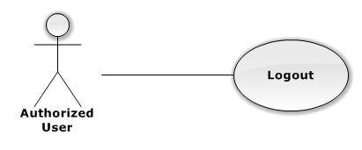

###### **3.2.2.4.1 Login**

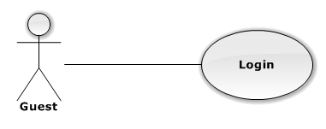

|  |  |  |  |  |
| --- | --- | --- | --- | --- |
| USE CASE – LOGIN | | | | |
| Use-case No. | UC04.01 | Use-case Version | | 1.0 |
| Use-case Name | Login | | | |
| Author | DuyDQ | | | |
| Date | 01/06/2013 | Priority | Normal | |
| **Actor:** Guest  **Summary:** This use case is about how actor login to website  **Goal:** Login to system successful  **Triggers:** N/A  **Pre-conditions:** No user has logged into system when access to home page  **Post-conditions:** Actor logged into the system successful  **Main Success Scenario:**   |  |  |  | | --- | --- | --- | | Step | Actor Action | System Response | | 1 | Click on “Đăng nhập” button | Navigate to login page | | 2 | Fill mandatory fields and click “Đăng nhập” button | Navigate to Home page with username at the top right |   **Alternative Scenario:** N/A  **Exceptions:**   |  |  |  | | --- | --- | --- | | Step | Actor Action | System Response | | 1 | Same as Main Succes Scenario | | | 2 | Does not fill all required field | Display warning message to notify the missing field | | 2 | Enter invalid data (wrong password or wrong username) | Display warning message “Tên đăng nhập hoặc mật khẩu không đúng” |   **Relationships:**  N/A  **Business Rules:** N/A | | | | |

###### **3.2.2.4.3 View Event Detail**



|  |  |  |  |  |
| --- | --- | --- | --- | --- |
| USE CASE – VIEW EVENT DETAIL | | | | |
| Use-case No. | UC04.03 | Use-case Version | | 1.0 |
| Use-case Name | View Event Detail | | | |
| Author | DuyDQ | | | |
| Date | 01/06/2013 | Priority | Normal | |
| **Actor:** Guest  **Summary:** This use case is about how actor views event detail  **Goal:** Actor can view event detail successful  **Triggers:** N/A  **Pre-conditions:** N/A  **Post-conditions:** N/A  **Main Success Scenario:**   |  |  |  | | --- | --- | --- | | Step | Actor Action | System Response | | 1 | Click on an event | Navigate to Event page |   **Alternative Scenario:** N/A  **Exceptions:** N/A  **Relationships:**  N/A  **Business Rules:** N/A | | | | |

|  |  |  |  |
| --- | --- | --- | --- |
| Date | 01/06/2013 | Priority | Normal |
| **Actor:** Customer, Authorized User, Guest  **Summary:** This use case is about how actor sort ticket by price  **Goal:** Actor can sort ticket successful  **Triggers:** N/A  **Pre-conditions:** N/A  **Post-conditions:** N/A  **Main Success Scenario:**   |  |  |  | | --- | --- | --- | | Step | Actor Action | System Response | | 1 | Click on an event | - Navigate to Event page  - If there are tickets in this event, they are sorted by low to high price in ticket field | | 2 | Click on dropdown list “Giá từ thấp đến cao” and select “Giá từ cao đến thấp” | Tickets are sorted by high to low price in ticket field |   **Alternative Scenario:** N/A  **Exceptions:** N/A  **Relationships:**  N/A  **Business Rules:** N/A | | | |

###### **3.2.2.4.6 Sort Event**

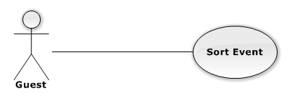

|  |  |  |  |  |
| --- | --- | --- | --- | --- |
| USE CASE – SORT EVENT | | | | |
| Use-case No. | UC04.06 | Use-case Version | | 1.0 |
| Use-case Name | Sort Event | | | |
| Author | DuyDQ | | | |
| Date | 01/06/2013 | Priority | Normal | |
| **Actor:** Customer, Authorized User, Guest  **Summary:** This use case is about how actor sort event  **Goal:** Actor can sort event successful  **Triggers:** N/A  **Pre-conditions:** N/A  **Post-conditions:** N/A  **Main Success Scenario:**   |  |  |  | | --- | --- | --- | | Step | Actor Action | System Response | | | | | |

##### **3.2.2.5 Auto System**

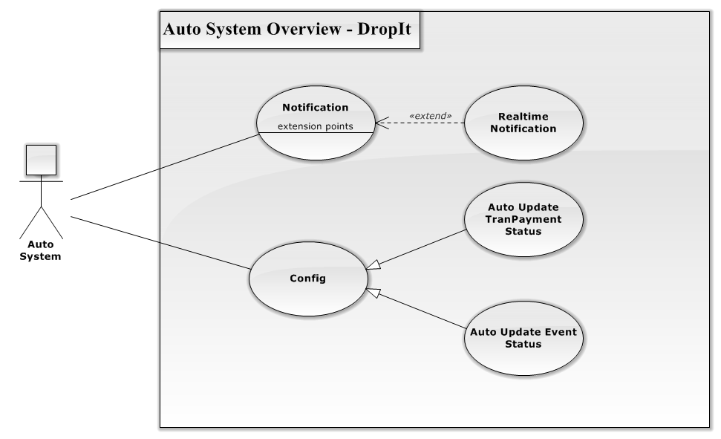

Figure 3.2.2.5.1 – Auto System Overview Diagram

###### **3.2.2.5.1 Notification**

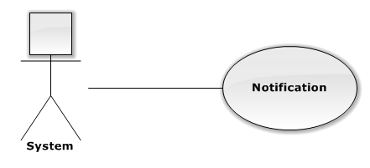

|  |  |  |  |  |
| --- | --- | --- | --- | --- |
| USE CASE – NOTIFICATION | | | | |
| Use-case No. | UC05.01 | Use-case Version | | 1.0 |
| Use-case Name | Notification | | | |
| Author | PhongLK | | | |
| Date | 01/06/2013 | Priority | Normal | |
| **Actor:** System  **Summary:** This use case is about how system notifies customer when their follow events have new request or ticket  **Goal:** User be notified about new request or new posted ticket of their followed events  **Triggers:** N/A  **Pre-conditions:** User post or request ticket | | | | |

|  |  |  |  |  |  |  |  |  |  |
| --- | --- | --- | --- | --- | --- | --- | --- | --- | --- |
| **Post-conditions:** N/A  **Main Success Scenario:**   |  |  |  | | --- | --- | --- | | Step | Actor Action | System Response | | 1 | Find users that followed event which has new ticket or request | List of user | | 2 | Push notification to user's notification table | Push notification |   **Alternative Scenario:** N/A  **Exceptions:** N/A  **Relationships:**  N/A  **Business Rules:** N/A |

###### **3.2.2.5.2 Real-Time Notification**

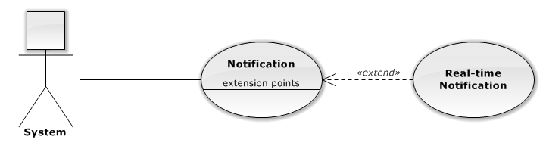

|  |  |  |  |  |
| --- | --- | --- | --- | --- |
| USE CASE – REAL-TIME NOTIFICATION | | | | |
| Use-case No. | UC05.02 | Use-case Version | | 1.0 |
| Use-case Name | Notification | | | |
| Author | PhongLK | | | |
| Date | 01/06/2013 | Priority | Normal | |
| **Actor:** System  **Summary:** This use case is about how system push real – time notification to customer  **Goal:** Online user receive notification when followed event has new request or ticket  **Triggers:** N/A  **Pre-conditions:** User posts or requests ticket  **Post-conditions:** N/A  **Main Success Scenario:**   |  |  |  | | --- | --- | --- | | Step | Actor Action | System Response | | 1 | Find online user that followed event which has new ticket or request | List of user | | | | | |

|  |  |  |  |
| --- | --- | --- | --- |
| |  |  |  | | --- | --- | --- | | 2 | Push notification to user's browser | Push notification success |   **Alternative Scenario:** N/A  **Exceptions:** N/A  **Relationships:**  N/A  **Business Rules:** N/A |

###### **3.2.2.5.3 Auto Update TranPayment Status**

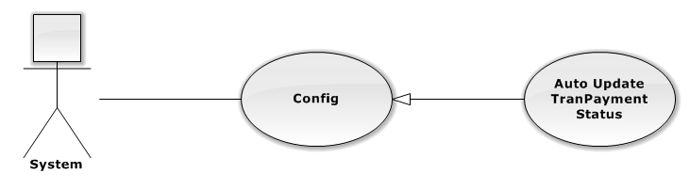

|  |  |  |  |  |
| --- | --- | --- | --- | --- |
| USE CASE – AUTO UPDATE TRANPAYMENT STATUS | | | | |
| Use-case No. | UC05.03 | Use-case Version | | 1.0 |
| Use-case Name | Notification | | | |
| Author | TungNT | | | |
| Date | 01/06/2013 | Priority | Normal | |
| **Actor:** System  **Summary:** This use case is about how the system auto changes TranPaymentStatus when out of date  **Goal:** The TranPaymentStatus turns into “Transferred” after 5 days since TranShipDate  **Triggers:** N/A  **Pre-conditions:** TranShipDate was created  **Post-conditions:** N/A  **Main Success Scenario:**   |  |  |  | | --- | --- | --- | | Step | Actor Action | System Response | | 1 | Select TranShipDate not null | Return all records that have TranShipDate | | 2 | Check TranShipDate with today | Return all records that have TranShipDate more than 5 days old | | 3 | Auto change TranPaymentStatus | Change TranPaymentStatus to “Transferred” |   **Alternative Scenario:** N/A  **Exceptions:** N/A | | | | |

|  |
| --- |
| **Relationships:**  N/A  **Business Rules:** N/A |

###### **3.2.2.5.4 Auto Update Event Status**

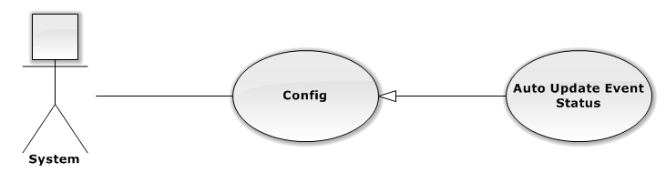

|  |  |  |  |  |
| --- | --- | --- | --- | --- |
| USE CASE – AUTO UPDATE EVENT STATUS | | | | |
| Use-case No. | UC05.04 | Use-case Version | | 1.0 |
| Use-case Name | Notification | | | |
| Author | TungNT | | | |
| Date | 01/06/2013 | Priority | Normal | |
| **Actor:** System  **Summary:** This use case is about how to change status of event when over hold date  **Goal:** The status of event turn into “OutDate”  **Triggers:** N/A  **Pre-conditions:** N/A  **Post-conditions:** N/A  **Main Success Scenario:**   |  |  |  | | --- | --- | --- | | Step | Actor Action | System Response | | 1 | Select all event has status not equal “Delete”and “OutDate” and not over hold date | Return all records of event that suitable | | 2 | Change event status to “OutDate” | Event status becomes “OutDate” |   **Alternative Scenario:** N/A  **Exceptions:** N/A  **Relationships:**  N/A  **Business Rules:** N/A | | | | |

*VenueController*

|  |  |  |
| --- | --- | --- |
| Method | Return type | Description |
| getInfo(int VenueId) | JsonResult | Get venue information |

##### **4.4.2.2 DropIt.Areas.Administration.Controllers**

*CategoryController*

|  |  |  |
| --- | --- | --- |
| Method | Return type | Description |
| Index(int CategoryStatus = 0) | ActionResult | Display Manage Category Index page |
| List(int jtStartIndex = -1, int jtPageSize = 0, string jtSorting = "CategoryName ASC", int CategoryStatus = -1) | JsonResult | Paging for category |
| Create() | ActionResult | Display Create Category page |
| Create(Category Category) | JsonResult | Allow admin to create new category |
| Edit(int Id) | ActionResult | Display Edit Category page |
| Edit(Category Category) | JsonResult | Allow admin to edit category |
| Active(int Id) | JsonResult | Active category base on CategoryId |
| Deactive(int Id) | JsonResult | Deactive category base on CategoryId |
| Delete(int Id) | JsonResult | Delete category base on CategoryId |

*DashboardController*

|  |  |  |
| --- | --- | --- |
| Method | Return type | Description |
| Index() | ActionResult | Display basic statistic about sell and buy ticket and current system status |

*EventController*

|  |  |  |
| --- | --- | --- |
| Method | Return type | Description |
| Index(int EventStatus = 0) | ActionResult | Display Manage Event Index page |
| List(int jtStartIndex = -1, int jtPageSize = 0, string jtSorting = "HoldDate ASC", int EventStatus = -1) | JsonResult | Paging for event |
| Create() | ActionResult | Display Create Event page |

#### Request Ticket

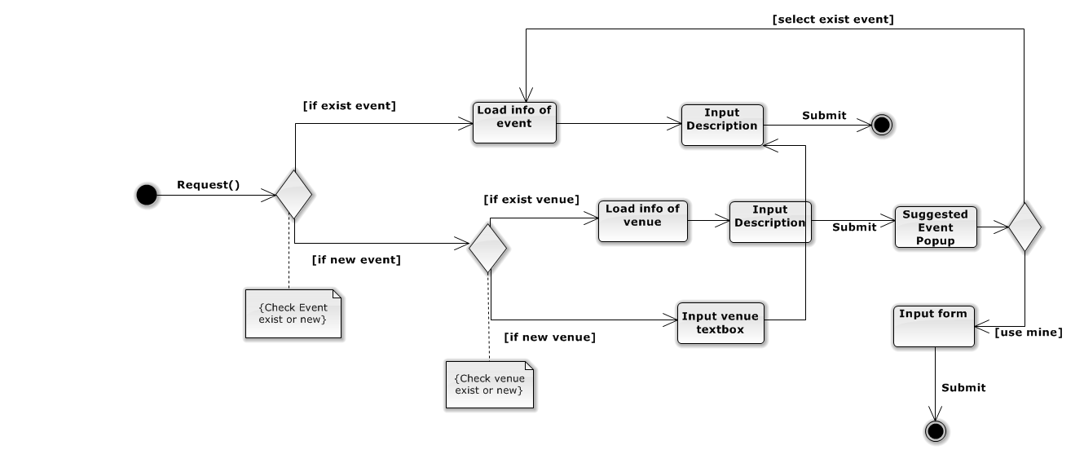

**Figure 4.6.2.1 –Request ticket activity diagram**

#### Buy Ticket

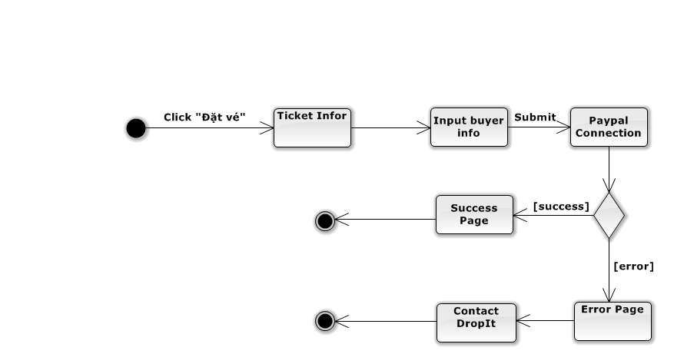

**Figure 4.6.3.1 –** **Buy ticket activity diagram**

|  |  |  |  |  |  |  |
| --- | --- | --- | --- | --- | --- | --- |
| |  |  |  | | --- | --- | --- | | 4 | Click on “Xóa” button | Show confirm message | | 5 | Click “Yes” button | Ticket is deleted successful |   **Alternative Scenario:** N/A  **Exceptions:** N/A  **Relationships:**  N/A  **Business Rules:** N/A |

###### **3.2.2.2.17 Receive Notification**

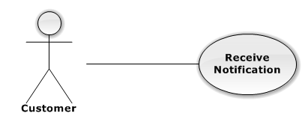

|  |  |  |  |  |
| --- | --- | --- | --- | --- |
| USE CASE – RECEIVE NOTIFICATION | | | | |
| Use-case No. | UC02.17 | Use-case Version | | 1.0 |
| Use-case Name | Receive Notification | | | |
| Author | PhongLK | | | |
| Date | 06/01/2013 | Priority | Normal | |
| **Actor:** Customer  **Summary:** This use case is about how to receive notification  **Goal:** Customer can receive notification successful  **Triggers:** N/A  **Pre-conditions:**  Event which customer followed has new request or ticket  **Post-conditions:** N/A  **Main Success Scenario:**   |  |  |  | | --- | --- | --- | | Step | Actor Action | System Response | | 1 | User login system successful | user sees number of notification at the bell label | | 2 | User click the bell label | User see detail of every notification |   **Alternative Scenario:** N/A | | | | |

|  |
| --- |
| **Exceptions:** N/A  **Relationships:**  N/A  **Business Rules:** N/A |

###### **3.2.2.2.18 Receive Real-time Notification**

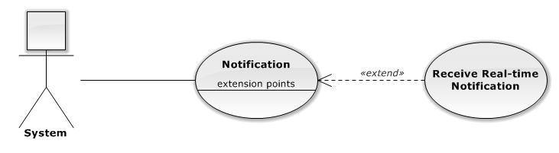

|  |  |  |  |  |
| --- | --- | --- | --- | --- |
| USE CASE – RECEIVE REAL-TIME NOTIFICATION | | | | |
| Use-case No. | UC02.18 | Use-case Version | | 1.0 |
| Use-case Name | Receive Real-time Notification | | | |
| Author | PhongLK | | | |
| Date | 06/01/2013 | Priority | Normal | |
| **Actor:** Customer  **Summary:** This use case is about how user receive real-time notification  **Goal:** Customer can receive real-time notification successful  **Triggers:** N/A  **Pre-conditions:**  Event which customer followed has new request or ticket and user is online  **Post-conditions:** N/A  **Main Success Scenario:**   |  |  |  | | --- | --- | --- | | Step | Actor Action | System Response | | 1 | User is online | User can see new notification at the bottom left |   **Alternative Scenario:** N/A  **Exceptions:** N/A | | | | |